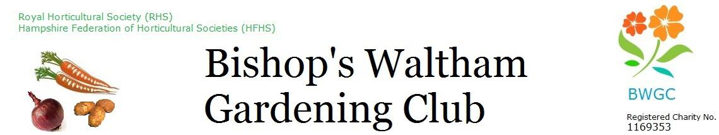
Minutes

Date: Monday 21st 2025 at The Shed
Time: 7:30 pm

Present: Maewyn Cumming (MC), Linda Haysom (LH), Ron Haysom (RH), Alison Perry (minutes) (AP), Gill Hamill (GH), Larry Mabey (LM), Anthea Mabey (AM), Robin Breach (RB), Kate Cassell (KC), Dave Bennett (DCB) Chair

Item | Minutes | Actions
- Apologies for absence | Gill Williams  Neal Davies
- Minutes of previous meeting | No further updates
- Actions list – Outstanding Actions from June Meeting | - DCB to approach PC about container on site – to do.  - DCB to get confirmation in writing from PC about filling in ditch - ongoing  - KC/LM/DCB to organise slamming posts to keep gates open when driving on tracks  - LM/RB/LH to confirm cost for BBQ.  - LM/RB to get tickets printed for BBQ  - MC to send out email to confirm BBQ date and start interest  - DCB – to contact Parish Council about getting keys for notice boards so that we can update ourself.
- Finance | See LH’s finance papers.  £27659.27 total in bank  Savings rates going down so less interest.  Budget setting for 25/26 – each budget holder to review and either bid for more or reduce. Check what funding needs to be set aside – speak to LH if needed  Minibus invoice – payment bounced back – LH has in hand  Instructions for buying from shop out of hours – LH to write something to be circulated at a later date  Donations – LH to write instructions for how we deal with this – to be circulated at a later date  No budget revisions this month. | - ALL – Get outstanding invoices to in as we get to end of FY.  - ALL – each budget holder to review budget and make decision as to whether need more or less for next year.  - LH to write instructions for buying from shop out of hours  - LH to write instructions for dealing with donations.
- Membership | 0 joined this month.
- Trading | Relatively quiet as usual. Email about shed voucher to go out after show comms to make sure members are aware.
- Allotments | No spare plots and 3/4 people on Waiting list
- Allotments - maintenance | All gates and butts numbered,  Gates signed off – gates and latches to be maintained by Ivor.  Instructions on gates, stop signs, Signage for gates  Gates to be opened on a sat/sun during shop opening hours. Trustees to make sure shut at end of shop hours  Payback came in – cleared boundaries and due to come for another 2/3 weeks,  Water butts – potential issue with standing water – KC and RH to clean.  If deer spotted inside fence, let trustees know.  Tues 29th deer herding – after this gates are closed.  Old gates – wooden one – offer back to council – KC to contact PC, metal gate – offer to PC/sell.  Trees – AM – TC and JM (PCllrs) Bargate to inspect trees, | - ALL - Shop vols to check gates opened at start of shop opening and closed at the end of the shop hours.  - KC – to contact PC to offer gates back to them. Possibly sell metal one.
- Allotments – other | n/a
- Dogs on plots | Some interest from members to consider reviewing policy on allowing dogs on plot. Nothing officially received by Secretary from any members and no request for motion to be taken to members. No further action required.
- Monthly programme | Sept meeting - Wildlife Gardening – and members show – classes will be 1.giant courgette comp, 2. apples (4 apples), 3. dahlias,  Nov – Ben Pope West Dean Gardens  If not him ask Ady Smith (swift man) | - GW to send info on Sept meeting to RB to be included in publicity.
- Social programme | BBQ – 10/08/25 – £6 each, £3 children under 12, BWGC members only -50 max. . MC to send list to AM for sign-up sheet. Start 5pm, BYOB, chairs, etc  Social – 10/10/25 – tickets ready to be printed, capture doc, ready to go, skittles, | - MC to send sign-up sheet to AM.  - MC to send out email for tickets to members.  - Social press to begin once show and BBQ complete.
- Annual Show | All in hand. Notice for photos/video – MC to do  2.15pm soberton strummers  Cake lady – 1.45pm  Cakes for Sat morning | - MC to do notice for photos/video to be placed at entrance.  - MC to do email for final request for cakes for teas/coffees.
- Update / publicity / social media | Instagram – MC to contact Simon about this.  Hampshire Chronicle – hopefully stuff to go in.  MC – is currently looking after website/FB and we are still looking for a Social Media trustee | - MC to contact SH about Instagram Account.
- Community orchard | All ok
- Charity programme/Butterfly Garden | Kids Treat – 06/07/25 – number of people ask about membership, well received  St Peters Fayre – Sept, still to decide on format – 20th Sept,  Student sponsorship – 2 potentials for coming year,  Greening event  Library – RH to confirm dates,  BWJS – LM/AP proposal for this to be annual
- Conflicts of Interest | - Form – to be used in the event if there is a potential conflict between trustee and event. This means we will have a paper trail and decisions are vindicated by impartial trustee. | - ALL – to use Conflict of Interest form when required.
- Any other business | - RHS Card – 50% off –  - AGM Date – Jan 2026 – 21st Jan @ St Peters Hall – wine and cheese,  - Mins for Aug meeting – MC to do  - MC – to do signs for Wickham Pantry and a ‘please help yourself’ for the give and take table outside  - LM/AP – BWJS AP to do write up and to add to agenda for sept meeting – onions, broad beans, potatoes. | - MC to send reminder to members about RHS card.  - AP to pull together doc for signing out of card  - AP to add to Sept meeting discussion on offer for BWJS for 25/26.  - AP to do write-up of the work with BWJS and send to RB.

Meeting finished at 2105

Next meeting: Monday 18th August 2025 at The Shed 7.30pm

